The right to listen
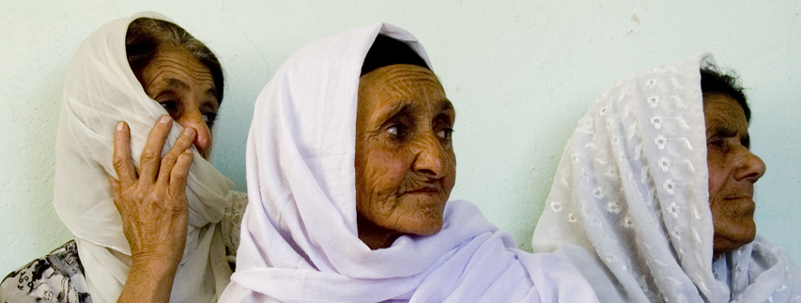
“In Afghanistan, when you educate a man, you educate an individual...when you educate a woman, you educate a family.”
- Greg Mortenson- Author Three Cups of Tea.

It was a hot summer day in Kabul, as we headed out of the smoggy, dust filled city, and the country side gradually gave way to cleaner air, and spacious desert. Members of our Equal Access outreach team headed to the Khoistan district in nearby Kapisa province, where we established a women’s listening circle around our human rights radio drama program. After a couple of hours of ever-changing landscape we arrived at our destination, a large traditional Afghan home. As we sat down, the room gradually began to fill with women. More than eighty in total came to the listening circle. There was tremendous diversity and women of all ages, ranging from unmarried high school aged girls to great grandmothers sat together listening to our human rights radio series. This cross section of women was incredibly encouraging, and the ensuing conversation was stimulating. The radio drama is produced and broadcast by Equal Access on our satellite radio channel Radio Danesh and FM partnership network of 28 stations across Afghanistan. The radio drama portrays women’s rights and human rights in the context of Islam and raises important questions about Islamic principles enshrined in the Qur’an. In each episode, the characters raise concerns, stimulating women to think about human rights topics as they relate to their daily lives. At the end of each drama, the presenters pose questions to the audience, which listening group members discuss, identifying ways to address these issues in their respective communities. Our vivacious Afghan women’s programming manager, a devout Muslim, engages women in gripping discussions, stimulating everyone involved — even the local village leader. Here we watched eighty illiterate women gather to discuss questions of fundamental importance to their rights and their religious beliefs through some of the only means available to them, radio programs. In this room hope and change were as palpable as the smell of tea, the taste of watermelon, and the sound of the radio.

“We were surprised to learn that Islamic rights were so close to international rights and Afghan constitutional rights. There are changes in the village. We learned about human rights and about the rights of women.”
- Local female listening group participant, Khoistan District

* This project is funded by the U.S. Department of State, the British Foreign and Commonwealth Office and the U.N. Democracy Fund.

